## List Docker CLI commands

Docker image --- help

Docker container --help

Cd .. #返回上级目录

Control +L # 清理 terminal 屏幕

docker run -it --rm nycdsa/linux-toolkits # 用完就删掉

Control + D # Quit the container

Read 4 write 2 exec 1 # 777 sample.txt

Cd sample_data cd sa (tab) # 自动弹出来

$ mkdir -p ~/examples/multiple/levels/down # make a nested directory

$ ls -R ~/examples # -R means list contents “recursively”

$ cp /etc/hosts nethosts *# copy a file into home directory with a new name*

Touch random.txt # touch后面的是文件名字

Sort --help # 帮助栏

Git rm filename

Git rm --cached huge.csv # remove a huge csv file from the repo completely

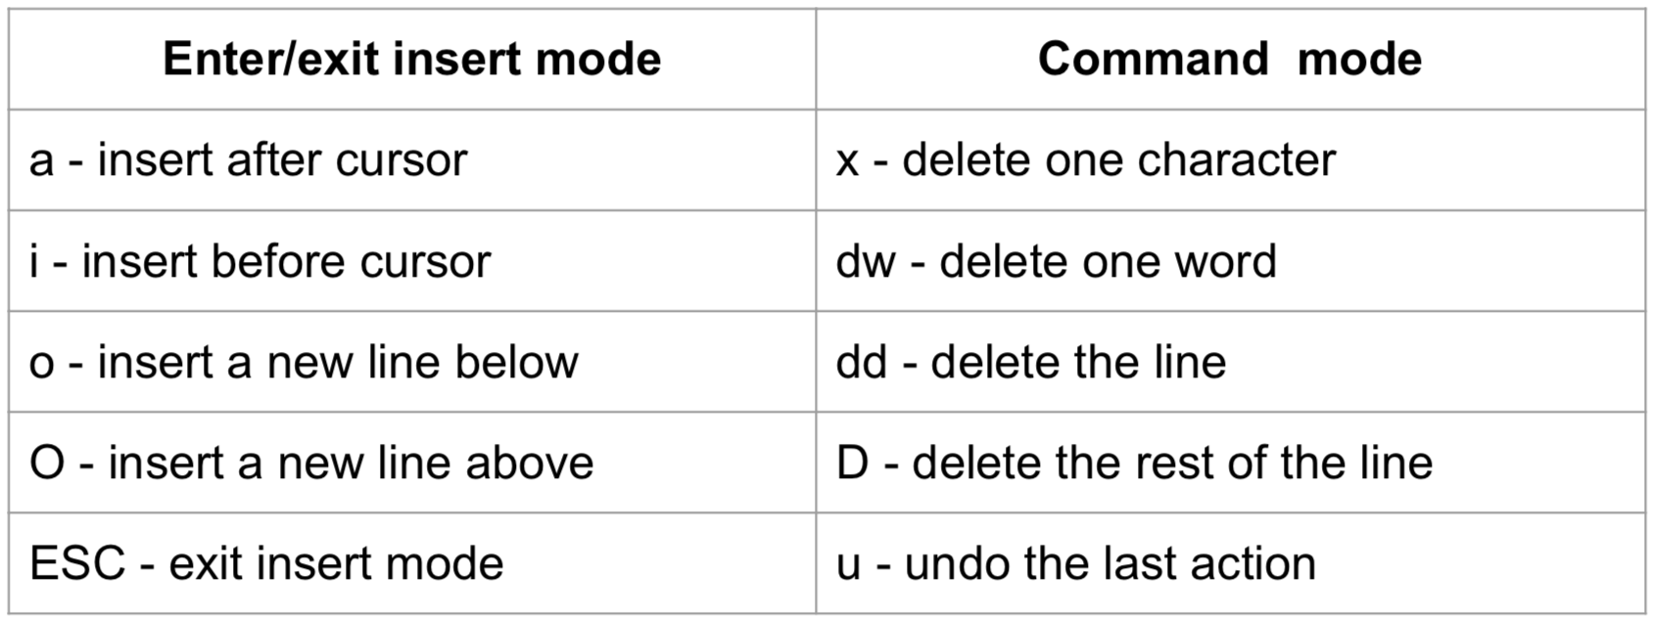

# Command mode $ # 把光标移到最后面 0 # 把光标移到最前面

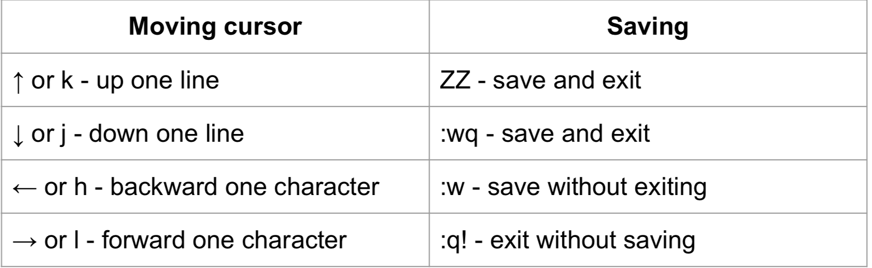

## Docker image commands

Docker image ls -a # List all images on this machine

Docker image rm <image id> # Remove specified image

Docker image rm $(docker image ls -a -q) # Remove all images from this machine

## Start/ enters a container

Docker run -it <image id> bash # ex. Docker run -it nycdsa/linux-toolkits bash

Docker run -it -p 8888:8888 <image id> #Map port 8888 to 8888

Docker run -it - v `pwd`:/home/ubuntu/workspace <image id> bash # bind host’s wd to container’s /home/ubuntu/workspace

Docker restart <container id> # restart a container

Docker exec -it <container id > bash #re-enter a container

## Docker container commands

Docker container ls == docker ps # List all running containers

Docker container ls -a == docker ps -a # List all container, even those not running

Docker container stop<container id> # Gracefully stop the specified container

Docker container kill <container id> # Force shutdown of the specified container

Docker container rm<container id> ==docker rm<container id> # Remove specified stopped container from this machine

Docker container rm -f <container id> #Force remove specified container from this machine

Docker container rm $(docker container ls -a -q) # Remove all stopped containers

Docker system prune #This will remove:

- all stopped containers

- all networks not used by at least one container

- all dangling images

- all dangling build cache

##echo(空格）‘hello world’>hello.txt # Create new file

##Bind mounts

Docker run -it -v<path>:/sample_data nycdsa/linux-toolkits bash

ex.Docker run -it -v`pwd`:/home/ubuntu/bootcamp nycdsa/linux-toolkits

ex.Docker run -it -v $(pwd):/home/ubuntu/bootcamp nycdsa/linux-toolkits

## Forwarding port

Docker run -it -p 8890:8888 nycdsa/linux-toolkits bash

docker run -it -p 8888:8888 -v $(pwd):/home/ubuntu nycdsa/linux-toolkits bash# bash 可省略

Hadoop :

docker run -it --rm -p 8088:8088 -p 50070:50070 -p 19888:19888 -v `pwd`:/home/hadoop/tutorials nycdsa/hadoop-bootcamp bash